Use at least 10 different HTML tags including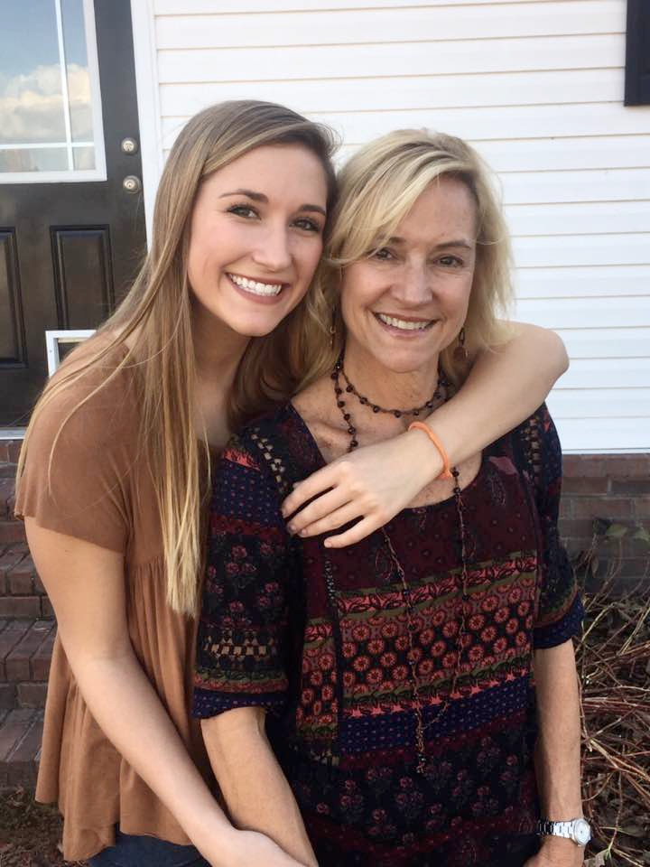

* Image
* Table

| Favorite Foods | My hobbies |
| --- | --- |
| Sushi | Volleyball |
| Chicken Fingers | Hiking |
| Steak | Spending time with my friends |

* Link
* Two tags not covered in the lab handouts.
* The required HTML tags (i.e. <html> <head>) do not count towards the previous requirement.
* Use at least 3 defined styles including 1 property not covered in the lab handouts.
* Your “main” page should be named “index.html”.
* Give us at least three paragraphs of content (about 150-200 words). Tell us something interesting!

My name is Erin Eads. I was born and raised in Greenville, South Carolina. I have two older siblings, an older sister and an older brother. My brother, Sean, is 26 and is a traveling physical therapist. My sister, Rebecca, is 24 and works for a marketing company. I also have two wonderful parents that still live in Greenville

Growing up I played soccer, basketball, and volleyball (56 words.) My true passion was volleyball, which I played year around all four years of high school. Student council was another passion of mine and I served on it all four years of high school as well

I now attend the University of Georgia and I am about to finish up my sophomore year. My major is Communication with Science and Disorder and I plan on going to Speech Therapy school for two years after college. My dream is to work as a Speech Therapist in the hospital for recovering stroke patients.

* Do not use any copyrighted content on your webpage. There’s a plethora of free content to use. Generally, it’s okay to use things that are labeled under the Creative Commons licensing scheme.
* You may consult guides like www.blooberry.com, www.w3schools.com, or even Google search to find a new tag, but be sure it is a standard tag (otherwise your page will not validate).
* Your page must validate as either HTML 4.01 Strict or XHTML. See the section “validation” below for more information. HTML version dependent validation errors are acceptable only if the webpage runs correctly.
* Your page should feel “cohesive.” That is, it shouldn’t look like you are randomly putting components on a page to meet the bare minimums.